**Life of Boris Super Slav** – a mobile game mainly directed to the Eastern European, Polish and Russian audience as it is the product of a Youtube channel that discusses and satirizes aspects of the behaviour and traditions of past communist countries.

**Dance Dance Revolution**- arcade game that can be both solo and multiplayer, popular with teens that enjoy challenges, music and dancing.

Making a game without narrative immersive:

* Game loop (tap, score, beat opponent)
* Challenge (schadenfreude + difficulty increases over time)
* Rythm
* In case we use food -> sensory immersion through images (also used in games such as Sushi Go, board game)

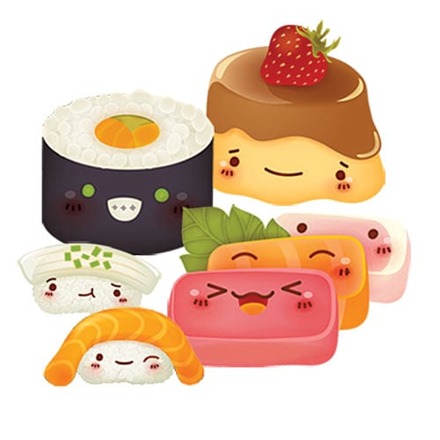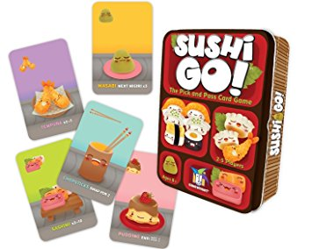

Possible users:

* Children
* Couples
* Friends

The game aims to address both genders, a wide range of ages (8-28) and is meant to be a short term acivity that could fill the gap when waiting for something (entertaining children in the car during a trip, couples while waiting in the airport or for the movie to start, friends while waiting for another to arrive).

To fit all chategories we are thinking to adopt neutral themes that are built around the ideas of astral elements or food. The style we settled on for our mobile game is one that derives from the concept of “cute”, costumised with anthropomorphisation.

Cuteness attracts the eye, keeps us focused and it is something that appeals to everyone, regardeless of the age and gender. (Games that do this: Hollow knight, Don’t Starve, Animal Crossing, Happy Hop).

Statistics Animal Crossing gender: <https://www.gamefaqs.com/boards/997811-animal-crossing-new-leaf/64064397> 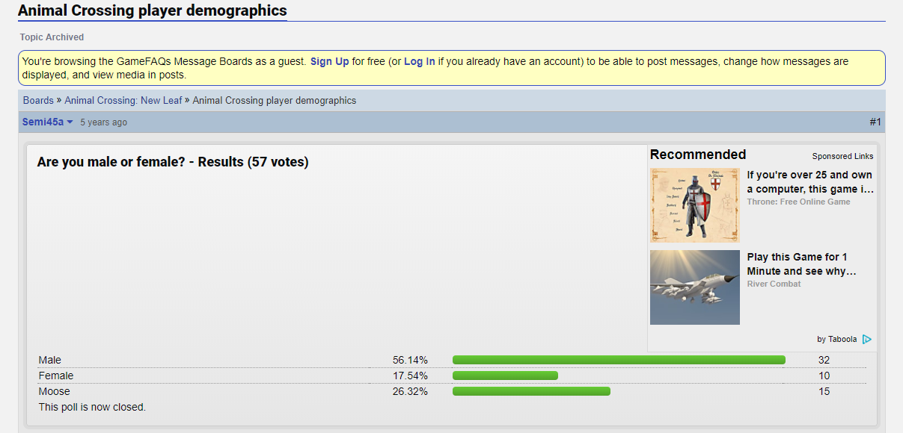

Statistics age Don’t Starve: <https://imgur.com/a/f9niX#jCBJBnw>

